PRESS RELEASE

COMMUNICATIONS AND MEDIA TEAM OF THE ASEAN SUMMIT 2023

No.17/SP/TKM-ASEAN2023/ENG/8/2023

ASEAN Maritime Outlook (AMO):
Indonesia's Initiative to Strengthen Comprehensive ASEAN Maritime Cooperation

Jakarta, 31 August 2023 – Enhancing maritime cooperation is one of fhe priorities of Indonesia's ASEAN Chairmanship in 2023. This was emphasised by Director for ASEAN Political and Security Cooperation, Rolliansyah Soemirat, amid preparations for the 43rd ASEAN Summit to be held next week on 5-7 September in Jakarta.

“Indonesia initiated the establishment of the ASEAN Maritime Outlook (AMO) which is a strategic document in strengthening the synergy of maritime cooperation under ASEAN’s three pillars,“ said Rolliansyah. In the future, AMO will serve as the main reference for maritime cooperation between ASEAN member-states with external partners, he continued.

The potential for maritime cooperation in the Indo-Pacific is enormous and multidimensional, strategically, politically, economically and socially for its people.

The first edition of the AMO, which was recently launched during Indonesia's Chairmanship period, comprehensively summarizes the progress of maritime cooperation in ASEAN. This will be a compass for ASEAN in determining the direction of maritime cooperation in the future. The AMO also provided recommendations on potential maritime cooperation undertaken by ASEAN sectoral bodies, mechanisms, and processes.

This publication serves as a practical reference in understanding maritime trends and challenges in the region, strengthening synergies, and guiding ASEAN to avoid duplication of efforts made among related mechanisms, bodies, and processes. With the identification of various developments, AMO will also open wider cooperation in relations with external partners.

The potential for maritime cooperation is also increasingly open along with the development of new maritime issues, such as cyber attacks on ships and port facilities, blue economy and renewable energy.

Going forward, the AMO, which is launched every three years, will serve as a practical reference for ASEAN Leaders, Ministers, Sectoral Bodies, and Partners in understanding and advancing ASEAN maritime cooperation.

This Outlook is expected to make a meaningful contribution to efforts to build a secure, stable and prosperous ASEAN Community, as well as further strengthen ASEAN's relations with external partners.

***

For further information, please contact the following:

Director of Information and Media of the Ministry of Foreign Affairs - Hartyo Harkomoyo (+62811831899).

Get more information at http://asean2023.id, https://infopublik.id/kategori/asean-2023, dan https://indonesia.go.id/kategori/ragam-asean-2023

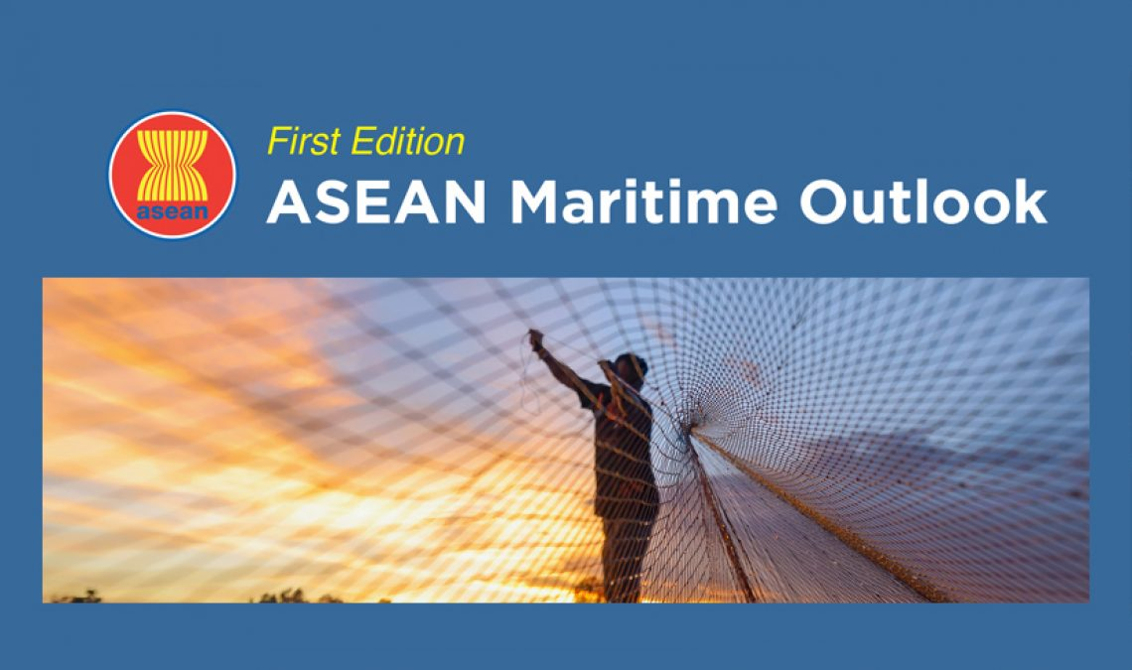

The first edition of the ASEAN Maritime Outlook (AMO) was launched at the 13th ASEAN Maritime Forum in Bali, Indonesia, on 1 August 2023. The AMO is a strategic document in strengthening the synergy of maritime cooperation under ASEAN’s three pillars. (Foto: asean.org)

